Here's a breakdown of Plato's "Allegory of the Cave":
Definition from "Literary Terms" (http://www.tnellen.com/cybereng/lit_terms/allegory.html): Allegory is a form of extended metaphor, in which objects, persons, and actions in a narrative, are equated with the meanings that lie outside the narrative itself. The underlying meaning has moral, social, religious, or political significance, and characters are often personifications of abstract ideas as charity, greed, or envy.
Thus an allegory is a story with two meanings, a literal meaning and a symbolic meaning.
Speakers in the allegory (each paragraph break indicates a switch in speaker):
- Socrates: read a biography of him here: http://www.philosophypages.com/ph/socr.htm. Socrates is the teacher and speaks first. His role is to help his students reach enlightenment. He believed the best way to do this was through the dialectic method, also called the Socratic method (http://en.wikipedia.org/wiki/Socratic_method). Basically, Socrates asks probing questions, setting up situations that the student can respond to, usually with a yes or no response in Plato's dialogues.
- Glaucon: read a short bio of him here: http://en.wikipedia.org/wiki/Glaucon. Glaucon is the student Socrates is teaching in this excerpt from Plato's Republic (http://en.wikipedia.org/wiki/Plato's_Republic; to read it: http://classics.mit.edu/Plato/republic.html), a work of 10 books that details Plato's ideal society.
Set up: Socrates has just finished discussing the worlds of being/becoming (http://faculty.washington.edu/smcohen/320/timaeus.htm), the dividing line (http://en.wikipedia.org/wiki/Analogy_of_the_divided_line), and the theory of forms (http://www.philosophypages.com/hy/2f.htm#forms). Now, he addresses the issue of how anyone becomes enlightened in this world of becoming. Since enlightenment is a mental/spiritual act, not a physical one, Socrates gives Glaucon the allegory of people trapped in a cave in order to explain the soul's journey from darkness (ignorance) into light (truth/good/knowledge). This journey is composed of several steps:
1. People are locked in a dark cave. Chained from birth, they are unable to move their bodies and can only stare straight ahead at the wall of the cave. On this wall flash objects, like images on a movie theatre screen. The prisoners believe what they see is reality, but these objects are merely shadows thrown against the wall by objects behind the prisoners. A fire behind these real objects (or "forms" as Socrates calls them) creates the shadows. As these objects (including people) walk in front of the fire, some of them speak, and the prisoners hear the echo of their voices and believe that these faint echoes are real words/sounds as well. Along the side of the cave is a rocky and steep path leading to the mouth of the cave. At the mouth, there is a faint glimpse of the sun.
2. A prisoner somehow gets free (Socrates does not explain how. Since this is his allegory on how we become enlightened, it's safe to guess that this can happen in many ways - at times by external forces and sometimes because of internal forces - ourselves). Since the prisoner has been chained since birth, even moving about is painful. He stumbles and is unsteady. Something compels him up the steep path to the mouth of the cave. This trip is difficult, and once the prisoner reaches the mouth of the cave and is in the light of the sun, he may try to return to the darkness because he is in such pain. But the force that compels him won't let him return.
3. Once outside, the prisoner will be blinded by the sun and at first cannot see. Eventually, he will begin seeing shadows and outlines of objects. Next, he will begin growing accustomed to the light and can distinguish one object from another. He can see the reflection of the brightest objects in water (sun and moon). Last, he can look at the sun itself. The sun represents good, which for Socrates is truth/knowledge. Basking in the sun, the prisoner sees truth. He realizes that life in the cave was an illusion, and that the honors bestowed there are meaningless.
4. Though the ex-prisoner might want to stay in the sun, meditating on truth, he cannot. His duty is to return to the cave and let others know truth. When he enters the cave again, though, his eyes will not be able to see in the dark any longer. He will stumble and look foolish. His words will not make sense. Some will mock him, others will fear him. Some will try to kill him because he is trying to bring change. Socrates says that those who return will at first not even be able to compete with prisoners because the darkness is so foreign to them. They must learn how to see in the dark again in order to communicate to the prisoners.
5. Socrates then tells Glaucon that the cave is the prison house of the soul, and that the journey out of it is equal to the soul's journey to enlightenment. Because of this, he says that educators who believe people have to be taught in order to know anything are wrong. In fact, everything we need to obtain enlightenment is within us already. We only have to work to unlock it. Socrates is not talking about finite knowledge, such as historic dates or who landed on the moon first. Instead, he is talking about the knowledge that is more ethical, that is governed by reason and mathematics.
6. Socrates believes that there is one art that promotes such enlightenment and that this type of wisdom is divine (there are many types of wisdom, but that which leads to enlightenment is what's being discussed here - philosophy). Because this is divine, understanding it means a wholehearted effort. One cannot partially attain it. Here, he mentions the clever rogue - a person who has wisdom, but has only accepted it as a means to gain advantage over others as opposed to the philosopher-king (as Plato calls him) who uses his wisdom to better society and others. Socrates then states that some clever rogues are created because society makes them. If a person is not given the right kind of care, then he can go astray. Socrates, in another work, likens our soul to a charioteer driving 2 horses, one black and one white. The black horse is evil, and the white horse is good. Good judgment holds the reins, and if the dark horse is in control, then the clever rogue wins. If the white horse is in control, then the philosopher king wins because the soul can escape the prison here and rise close to the world of being (for more, watch the Youtube video here: http://youtube.com/watch?v=WgPJUTltITk). With the right training, good judgment has a better chance of maintaining control over evil. Socrates also suggests that people can become rogues because they do not have the basic necessities of life. This might be explained by using Maslow's Hierarchy of Needs (diagram below; read more here: http://en.wikipedia.org/wiki/Maslow's_hierarchy_of_needs). Maslow was an American psychologist who believed that people had needs that had to be met, and these needs were not all equal. The highest level, self-actualization, is similar to Plato's enlightenment. According to Maslow, it is harder for people to attain the upper levels of needs if any lower level is unmet. The most lowest level, also the largest, are physiological needs, such as eating and drinking (what Socrates mentions in the dialogue when discussing rogues). You can see below the other categories. Thus, Socrates seems to be suggesting that unless we create a society where people can have the time to focus on self-actualization, they will be more than likely distracted by meeting their more pressing needs. Think of how much more easier it would be to make good grades if you didn't have to work, worry about money, take care of your kids, etc. This is what Socrates is talking about. Remember, Plato's overall purpose in the Republic is to create an ideal society, and this would include social reform as well.
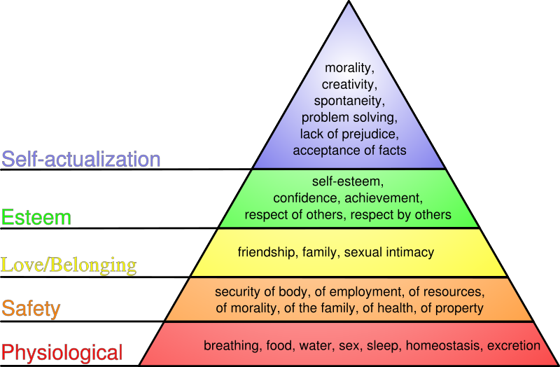
7. Socrates then begins to discuss who can help make this change in society. He says that neither the uneducated nor the eternal student qualifies. The first doesn't have the skills to focus on one direction and the second do not feel the need because they already live in what they think is paradise and do not want to leave their pleasant life. Instead, those who have created the 'state' must take the best and brightest, educate them in this method, and them force them to return to the cave. This is not cruel because the state does not exist to privilege any one class but to create a world where our happiness depends on the happiness of everyone else. So those who are educated and know the light of truth must return to the cave and learn to see in the dark. Once they have adapted to the dark, they will be able to see 10,000 times better than the prisoners. They can discern shadows from truth and thus can lead the state. He says
And thus our State which is also yours will be a reality, and not a dream only, and will be administered in a spirit unlike that of other States, in which men fight with one another about shadows only and are distracted in the struggle for power, which in their eyes is a great good. Whereas the truth is that the State in which the rulers are most reluctant to govern is always the best and most quietly governed, and the State in which they are most eager, the worst.
Socrates says that those who do not want to rule because they place their importance on things of the next world not on this world are the perfect people to rule because they are rich in wisdom and virtue. People who want to rule are usually hungry for power or money and will thus be corrupted and cannot rule the state wisely or justly. Philosophers, because they look down on politics, are the best then to be these leaders.

